1. 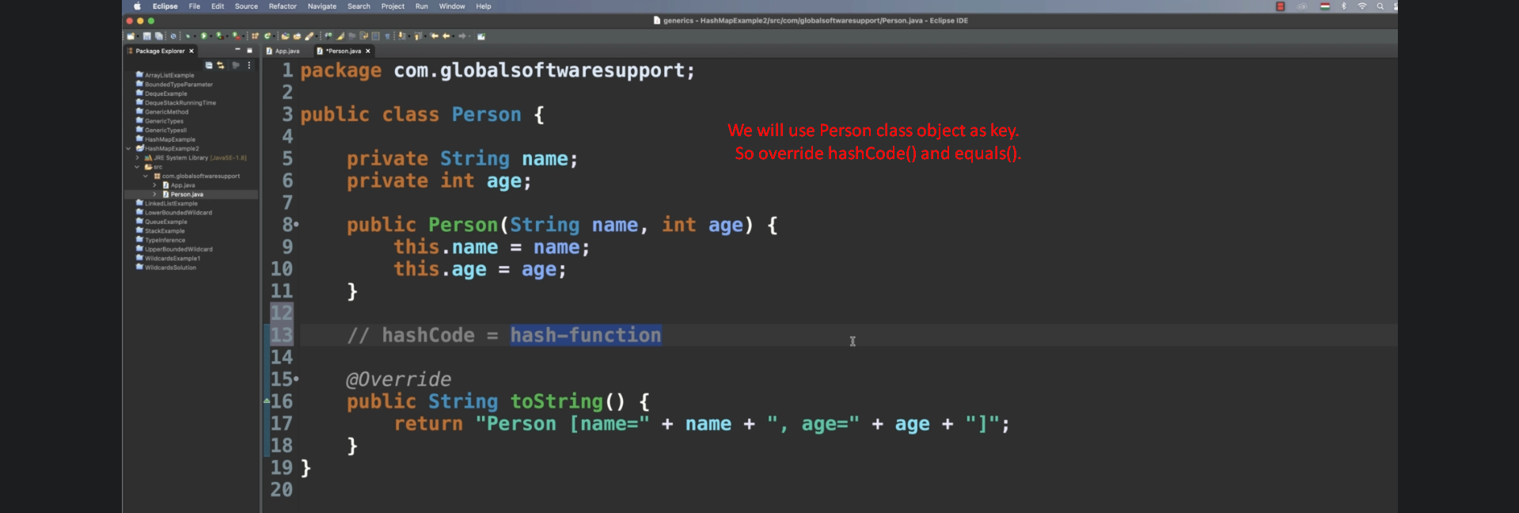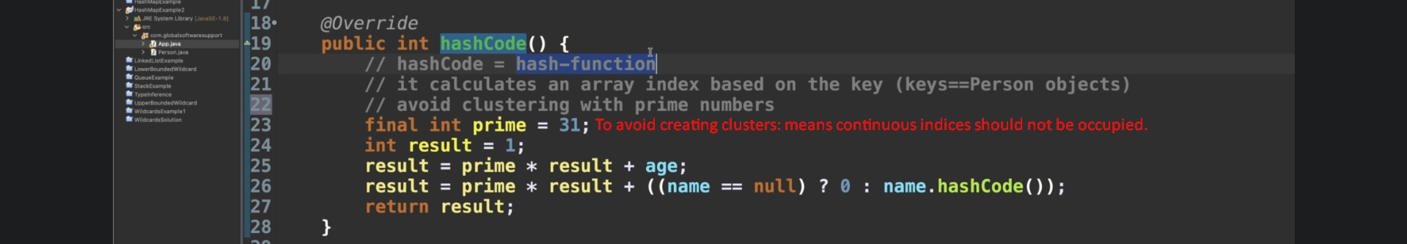
2. 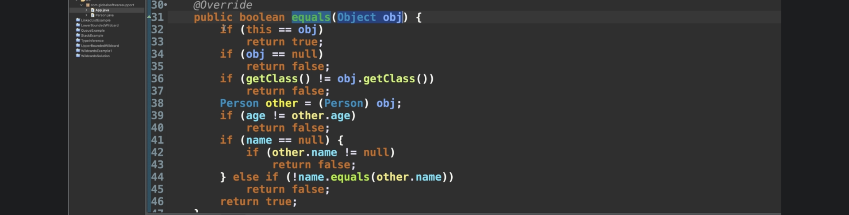
3. 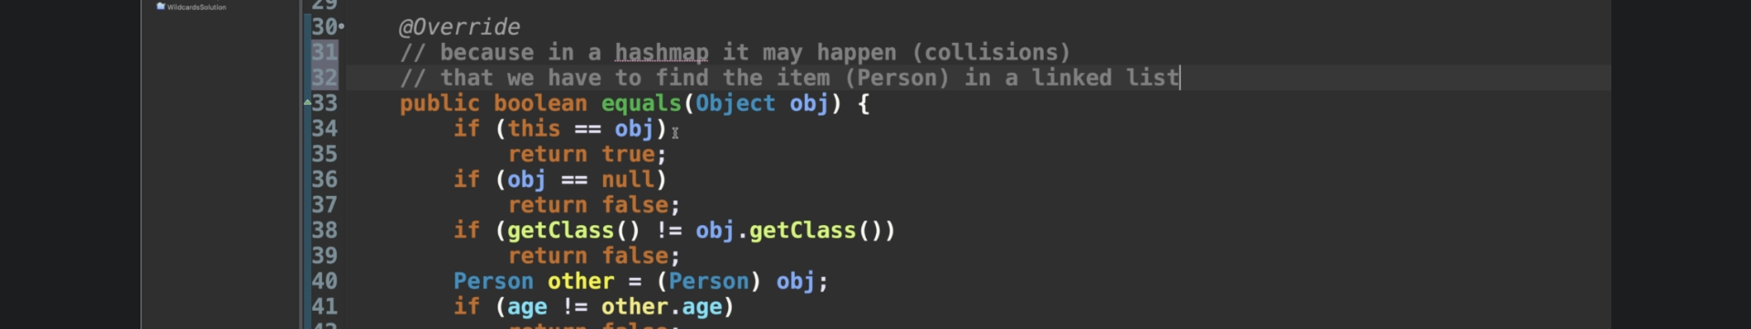
4. See my Algo course.